

18th JUNIOR RHYTHMIC GYMNASTICS ASIAN CHAMPIONSHIPS

(Individuals and Groups)
08 – 10 October 2021
Ulaanbaatar MONGOLIA

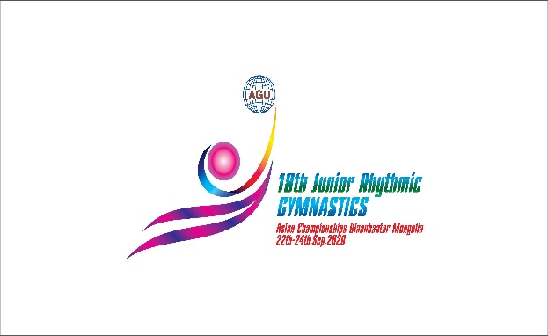

Form to be sent to: mglrgtc@gmail.com
Organizing Committee / Host Federation
THE MONGOLIAN GYMNASTICS FEDERATION (MGF)
Contact Person: Mr. Galbadrakh YERUULBAT
E-mail: mglgym@gmail.com / mglrgtc@gmail.com
Tel: +976-99995158; +976-95111153
Deadline: 22.Sep.2021
Travel Schedule Form

Federation |  | Contact person:
Federation |  | Phone:
Federation |  | E-mail:
If the team delegation is scheduled on more than one transportation mean, please complete one (1) form for
each transportation mean. For earlier arrival or later departure please contact the OC.
Arrival information
# of persons |  |  | # of luggage
Date: |  |  |  |  | Arrival time
By airplane | Airport: |  |  | Flight # |  | From
By train | Station: |  |  | Train # |  | From
By bus (complete if needed) | Station: |  |  | Bus # |  | From
By car

Departure information
# of persons |  |  | # of luggage
Date: |  |  |  |  | Departure time
By airplane | Airport: |  |  | Flight # |  | To
By train | Station: |  |  | Train # |  | To
By bus (complete if needed) | Station: |  |  | Bus # |  | To
By car

Local transport cost (complete if applicable) | Number  at XXX/person |  | Total

Place and date | Seal of the NF | NF authorised signature
 |  | Signature of the President or Secretary General of the participating FIG affiliated NF

